
Day-03 Report
Samra Ishaq

August 8, 2026
MATalogics Internship

Task 1: GitHub Setup
I created a GitHub account, installed Git on my local system, and configured it with my name and email so that my commits are correctly attributed.

Git Configuration Commands
git config --global user.name "Samra-Ishaq"
git config --global user.email "samraishaq929@gmail.com"
git init
These commands set my identity globally for all repositories on my machine and initialize a new local Git repository.

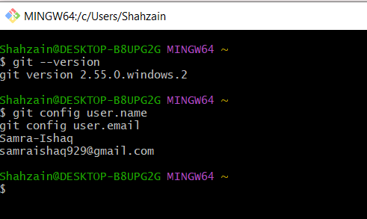

Practiced Commands
I practiced the following core Git commands in the terminal (CMD / VS Code terminal):
git clone https://github.com/Samra-Ishaq/git-practice.git
Downloads a full copy of a remote repository, including its entire history, to my local machine.
git add .
Stages all changed and new files in the working directory, preparing them to be committed.
git commit -m "Add test.txt for practice"
Saves the staged changes as a new snapshot (commit) in the local repository history, with a descriptive message.
git push
Uploads my local commits to the remote repository on GitHub, so they are visible online and to collaborators.
git pull
Fetches and merges the latest changes from the remote repository into my local branch, keeping it up to date.
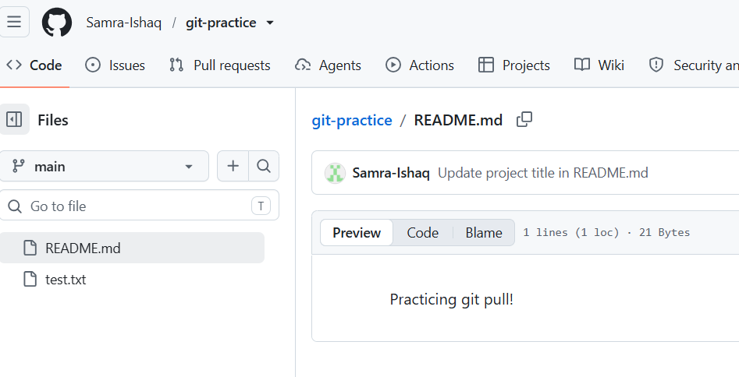

Task 2: Internship Repository
I created a public GitHub repository named AI-Automation-Internship to store all my daily internship tasks, starting with a README.md describing the repository's purpose and structure.
Repository Link : https://github.com/Samra-Ishaq/AI-Automation-Internship

Task 3: Open-Source Contribution
For this task, I explored an open-source repository related to n8n automation workflows: awesome-n8n-templates, a curated collection of reusable n8n workflow templates.

Steps I Followed
- Searched GitHub and selected the awesome-n8n-templates repository (topic: n8n / No-Code Automation).
- Forked the repository to my own GitHub account (Samra-Ishaq/awesome-n8n-templates).
- Cloned my fork locally and explored its structure, focusing on the OpenAI_and_LLMs section — one of the most-used categories with 17 templates.
- Noticed that several template descriptions in the README were overly brief one-liners (e.g. "Basic AI chat agent."), inconsistent with the more detailed descriptions used elsewhere in the file.
- Rewrote and expanded the descriptions for 5 templates: AI agent chat, Advanced AI Demo, AI agent that can scrape webpages, AI Crew to Automate Fundamental Stock Analysis – Q&A Workflow, and AI Customer feedback sentiment analysis.
- Added a "My Contribution" section to the README documenting the change for transparency.
- Committed the changes across two commits with clear, descriptive messages.
- Pushed the updates to my fork on GitHub.
- Opened Pull Request #177 to the original repository.Git Commands Practiced
git clone https://github.com/Samra-Ishaq/awesome-n8n-templates.git
git checkout -b feature/improve-openai-descriptions
git add .
git commit -m "Improve descriptions for AI agent templates in OpenAI_and_LLMs README section"
git commit -m "Add My Contribution section documenting README improvements"
git push origin feature/improve-openai-descriptions

Links
Original repository:
https://github.com/enescingoz/awesome-n8n-templates
My fork:
https://github.com/Samra-Ishaq/awesome-n8n-templates
My Pull Request:
https://github.com/enescingoz/awesome-n8n-templates/pull/177

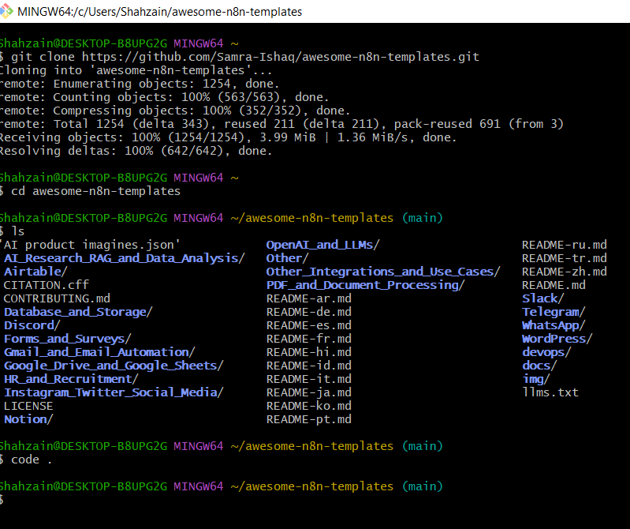

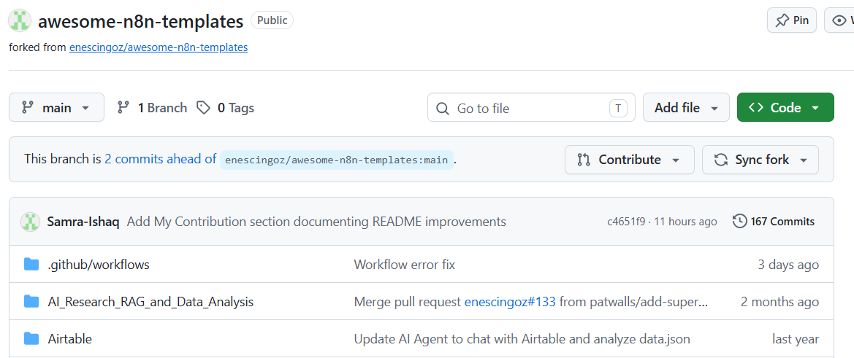

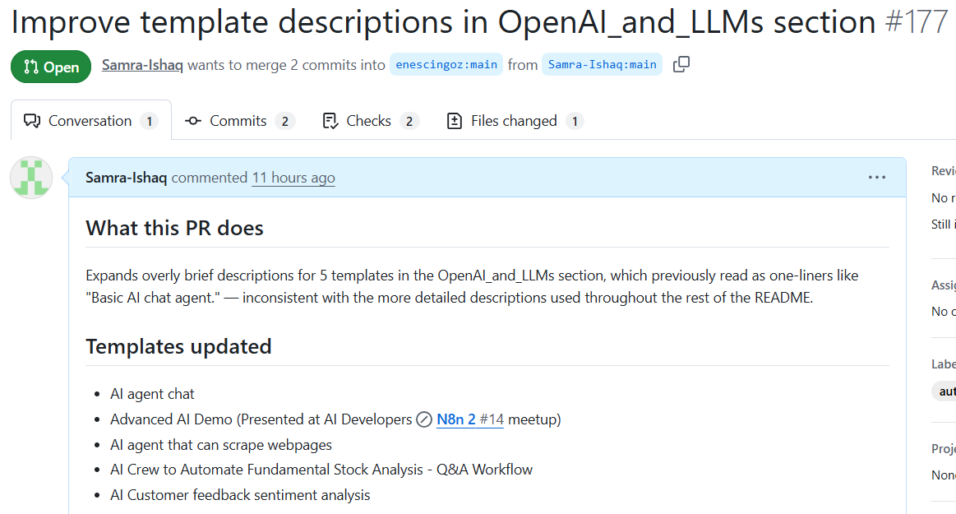

Module 2: API Fundamentals

What is an API?
An API (Application Programming Interface) is a set of rules that allows two different software applications to communicate with each other. It acts like a messenger: one application sends a request through the API, and the API delivers that request to another system, then brings back the response. APIs let developers use features or data from another application, service, or platform without needing to know how that system works internally.

REST API
A REST API (Representational State Transfer) is a common way of designing APIs that use standard HTTP requests to allow communication between a client (such as a web browser, mobile app, or Postman) and a server. The client sends a request to a specific URL (called an endpoint), and the server processes it and sends back a response, usually in JSON format. REST APIs are stateless, meaning each request from the client contains all the information the server needs — the server does not remember previous requests.

HTTP Methods
HTTP methods define the type of action a client wants to perform on a resource:
- GET — Retrieves data from the server without changing anything. Example: GET /leads returns a list of all leads.
- POST — Sends new data to the server to create a resource. Example: POST /leads with a JSON body creates a new lead entry.
- PUT — Updates an existing resource, usually replacing it entirely. Example: PUT /leads/5 updates the lead with ID 5 with new details.
- DELETE — Removes a resource from the server. Example: DELETE /leads/5 deletes the lead with ID 5.

HTTP Status Codes
Code | Meaning | Explanation
200 | OK | The request was successful, and the server returned the expected data.
201 | Created | A new resource was successfully created (commonly returned after a POST request).
400 | Bad Request | The request was malformed or missing required data; the server could not understand it.
401 | Unauthorized | The request lacks valid authentication credentials to access the resource.
404 | Not Found | The requested resource or endpoint does not exist on the server.
500 | Internal Server Error | Something went wrong on the server's side while processing the request.

Headers
- Content-Type — Tells the server what format the data being sent is in, e.g. application/json, so it can be parsed correctly.
- Authorization — Carries credentials (such as an API key or token) needed to prove the client is allowed to access the resource.
- Accept — Tells the server what response format the client expects back, e.g. application/json or text/html.

Authentication
- API Keys — A unique string issued to a client/application, sent with each request to identify and authorize it. Simple to use but less secure if exposed.
- Bearer Tokens — A token (often from OAuth or JWT) sent in the Authorization header as 'Bearer <token>'. The server verifies the token to confirm the request is authenticated, commonly used for session-based or time-limited access.

Module 3: POSTMAN

1. Objective
This report documents the design, implementation, and testing of a complete Lead Management API built using n8n Webhooks, with Google Sheets as the data store. Postman was used to send and validate requests against each API endpoint. The API supports four operations: creating a lead, retrieving all leads, updating a lead, and deleting a lead.

2. Tools Used
- n8n — workflow automation platform used to build the webhook-based API
- Google Sheets — used as the backend data store for lead records
- Postman — used to create, test, and document API requests via a collection and environment

3. Google Sheets Setup
A Google Sheet named "Lead Management" was created to store all lead records, with the following column structure: Name, Email, Phone, Company, Interest, and Created At. This sheet is used by all four n8n sub-workflows to append, read, update, and delete lead rows.

3.1 Sheet Data After Testing

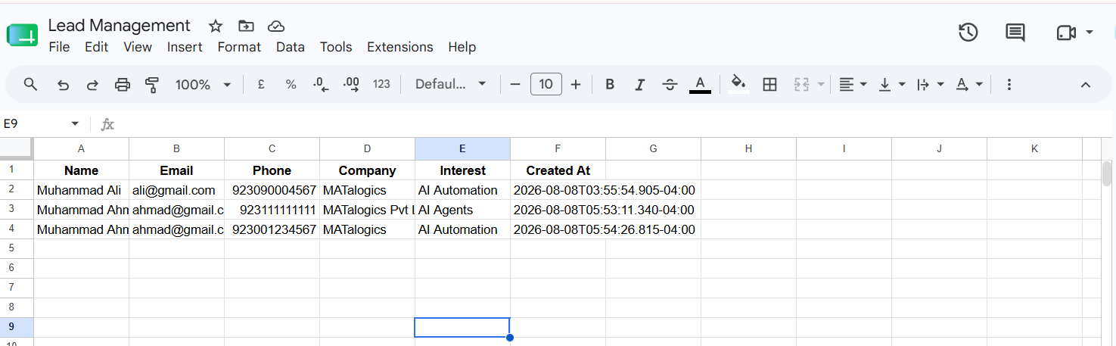4. n8n Workflow Design
A single n8n workflow was built containing four independent branches, each triggered by its own Webhook node, matching the structure. Each branch performs validation and/or lookup logic before reading from or writing to the Google Sheet, and returns a JSON response via a Respond to Webhook node.

4.1 Overall Workflow Canvas
The complete workflow, showing all four branches (Create, Get All, Update, Delete) side by side in a single canvas.

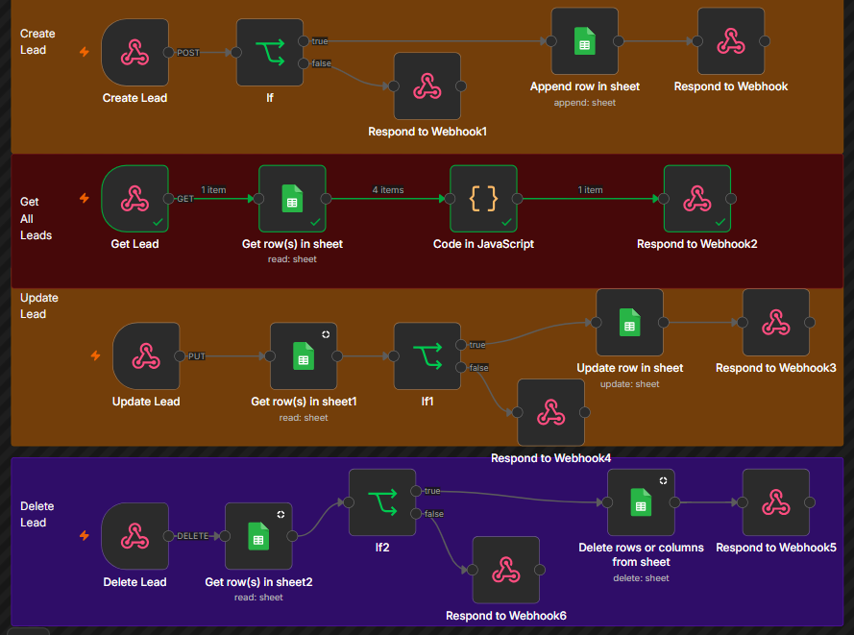

5. Postman Setup

5.1 Workspace and Collections
A Postman workspace named "Internship" was created, containing two collections: a practice collection ("MATalogics Internship Collection") used to learn GET/POST requests, variables, authorization, and export; and the deliverable collection ("MATalogics Lead Management API") built against the live n8n workflow.

5.2 Collection Variables
A collection variable base_url was defined, storing the shared root of the n8n webhook URL. All four requests reference {{base_url}} followed by their specific endpoint path, so the entire collection can be repointed to a new server by editing a single value.

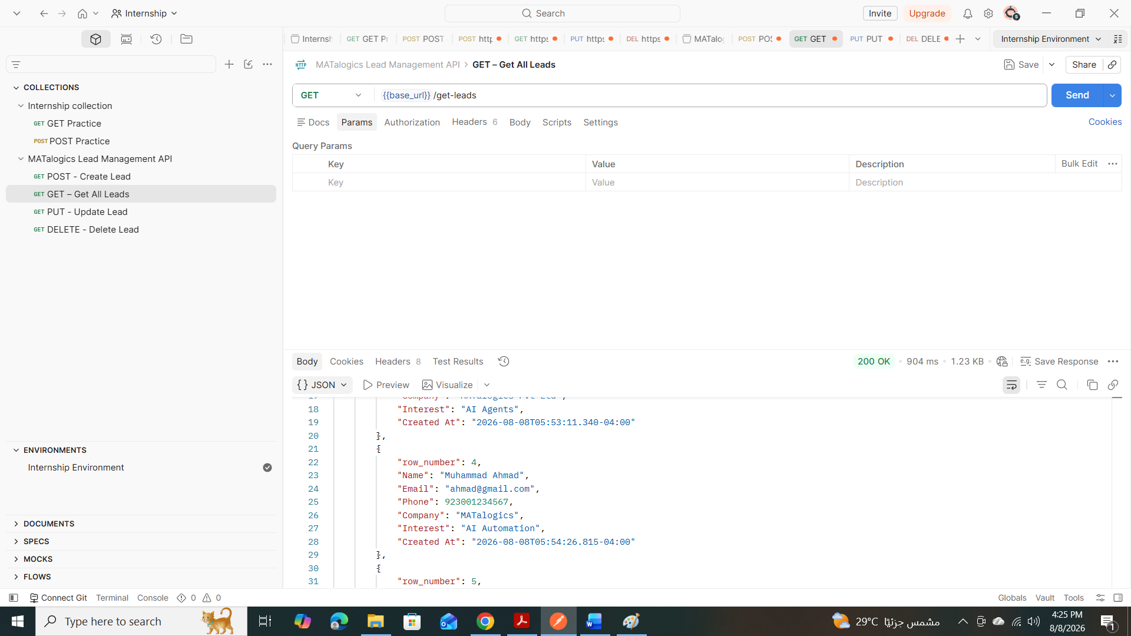5.3 Environment
A Postman Environment was also created and activated, storing the same base_url variable, to demonstrate the ability to separate environment-specific configuration (e.g. Development vs Production) from the collection itself.

6. End-to-End Testing
A full regression test was performed in sequence to confirm the API and underlying workflow behave correctly across all operations:
- POST a new lead → verified 200 response and new row in Google Sheets
- GET all leads → verified the new lead appears in the returned array
- PUT an update to the lead → verified 200 response and updated values in Google Sheets
- GET all leads → verified the updated values are reflected
- DELETE the lead → verified 200 response and row removal from Google Sheets
- GET all leads → verified the lead no longer appears
- Negative tests: missing required fields on Create returned 400; non-existent email on Update/Delete returned 404

7. Conclusion
The Lead Management API was successfully implemented as a single n8n workflow with four webhook-triggered branches, backed by Google Sheets for data storage, and fully tested through a dedicated Postman collection using collection variables, an environment, JSON request bodies, and correct HTTP methods and headers. All four operations — Create, Get All, Update, and Delete — were verified to work correctly, including handling of invalid and not-found cases.

